BDA Exp2: Sqoop

Aditya Tawade, BE4, 60

## **Part 1: Using sqoop to import data from mysql to hadoop**

**Step1:** Open terminal in cloudera

**Step2:** Login to mysql (username is “root” and password is “cloudera”).  
 **Command:** mysql -u root -pcloudera

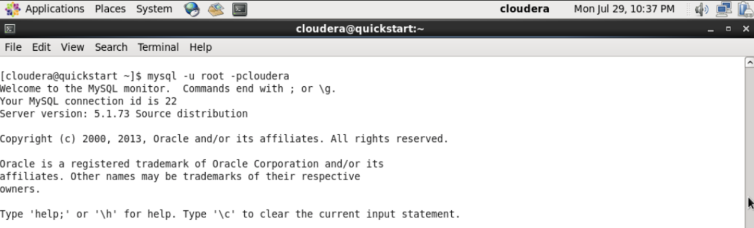

**Step 3:**

**(a) Create a database(db) and set it as current database.**

**(b) Create a table called employees and fill it up with data.**

**(c) Exit mysql.**

**Commands:**

CREATE DATABASE db;  
 USE db;

CREATE TABLE employees (

id INT NOT NULL PRIMARY KEY,

name VARCHAR(20),

deg VARCHAR(20),

salary INT,

dept VARCHAR(10)

);

INSERT INTO employees VALUES(1, ‘Aditya Tawade’, ‘CEO’,1000000, ‘SD’), (2, ‘Suraj Jagtap’ , ‘Janitor’,2, ‘SD’), (3, ‘Yug Solanki’, ‘Senior Developer’,100000, ‘SD’);

EXIT;

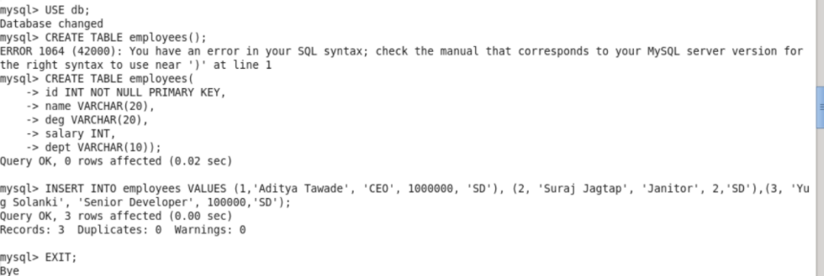

**Step 4:** Use sqoop to import the mysql table to hadoop

**Commands:**

sqoop import \

–connect jdbc:mysql://localhost/db \

–username root \

–table employees \

–password cloudera

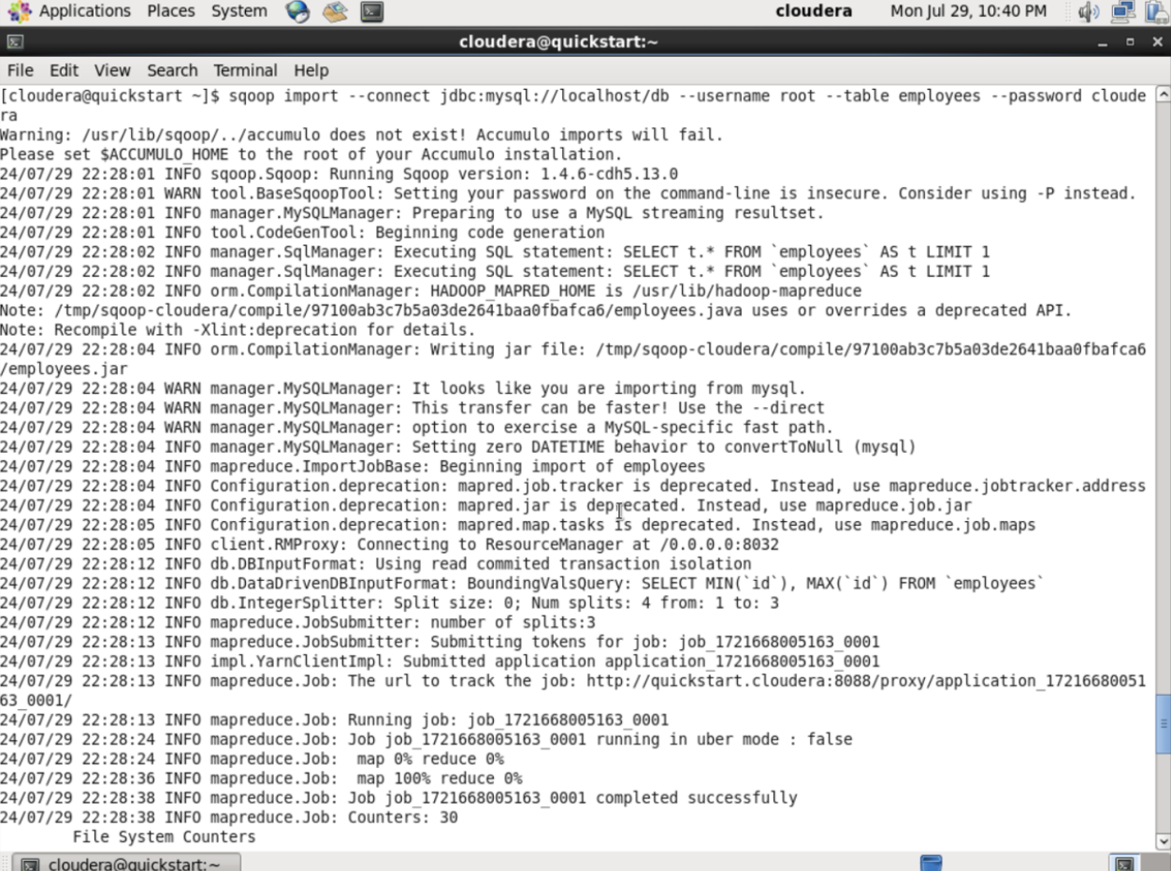

**Step 5:** Check whether the table is successfully imported to hadoop.

**Commands:**

hadoop fs -ls /user/cloudera/employees

hadoop fs -ls /user/cloudera/employees/part-m-00000 (might be different)

hadoop fs -ls /user/cloudera/employees/part-m-00001 (might be different)

hadoop fs -ls /user/cloudera/employees/part-m-00002 (might be different)

## **Part 2: Using sqoop to export table from hadoop to mysql.**

Now the data is present in hadoop, lets use scoop to export table from hadoop to mysql.

**Step 0:** Drop the table we created in Part 1 from mysql.

**Commands:**

mysql -u root -pcloudera

USE db;

DROP TABLE employees;

**Step 1:** Create table employees.

**Commands:**

CREATE TABLE employees(

id INT NOT NULL PRIMARY KEY;

name VARCHAR(20),

deg VARCHAR(20),

salary INT,

dept VARCHAR(10)

);

EXIT;

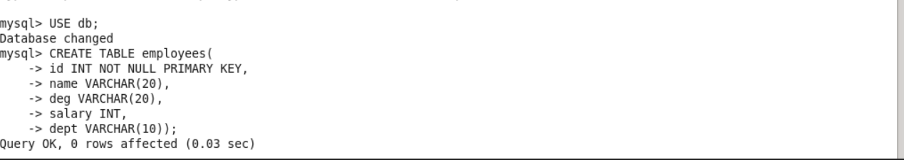

**Step 2:** Use sqoop to export table from hadoop to mysql.

**Commands:**

sqoop export \

–connect jdbc:mysql://localhost/db \

–username root \

–password cloudera \

–table employees \

–export dir /user/cloudera/employees \

–input-fields-terminated-by ‘,’

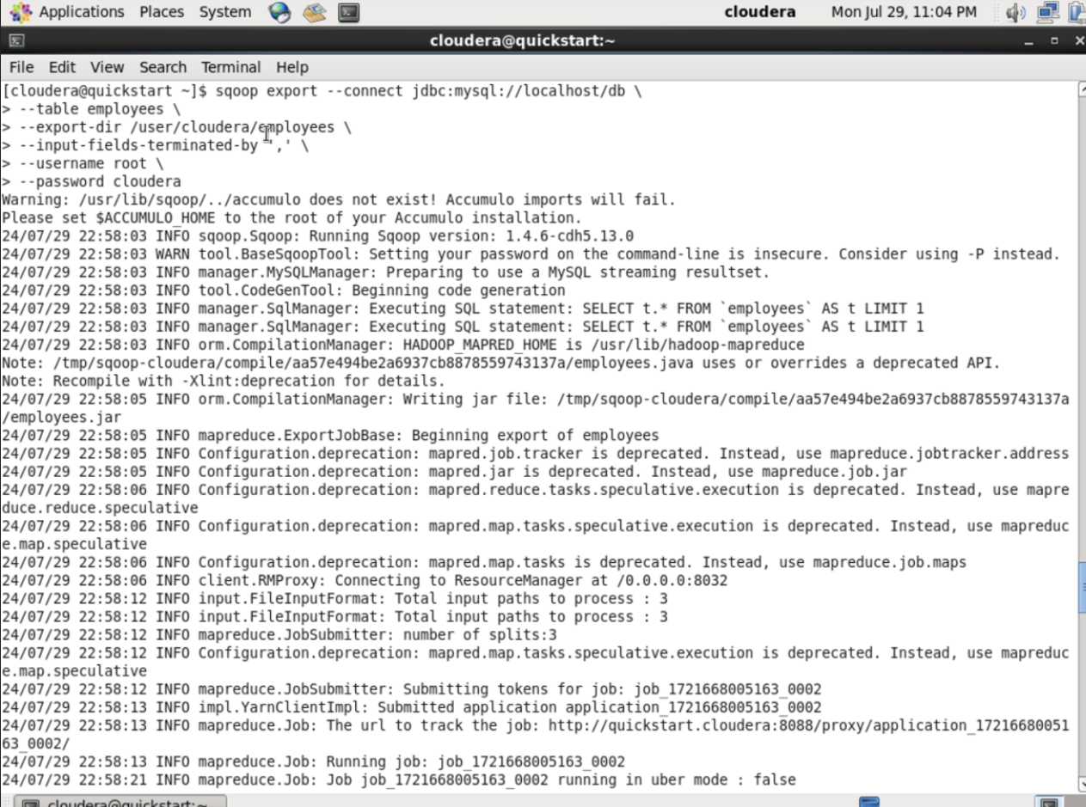

**Step 3:** Login to mysql and check if the table is exported successfully.

Commands:

Mysql -u root -pcloudera

USE db;

SELECT * FROM employees;

